Subcategories of Fingerprints Name ____________________
Forensics 352 – O’Dette Date ____________ Period ___

- Remember a loop has only one delta whereas a whorl has two deltas. Since central pocket loop and double loop has 2 deltas they are whorls not loops which is very confusing given their name.
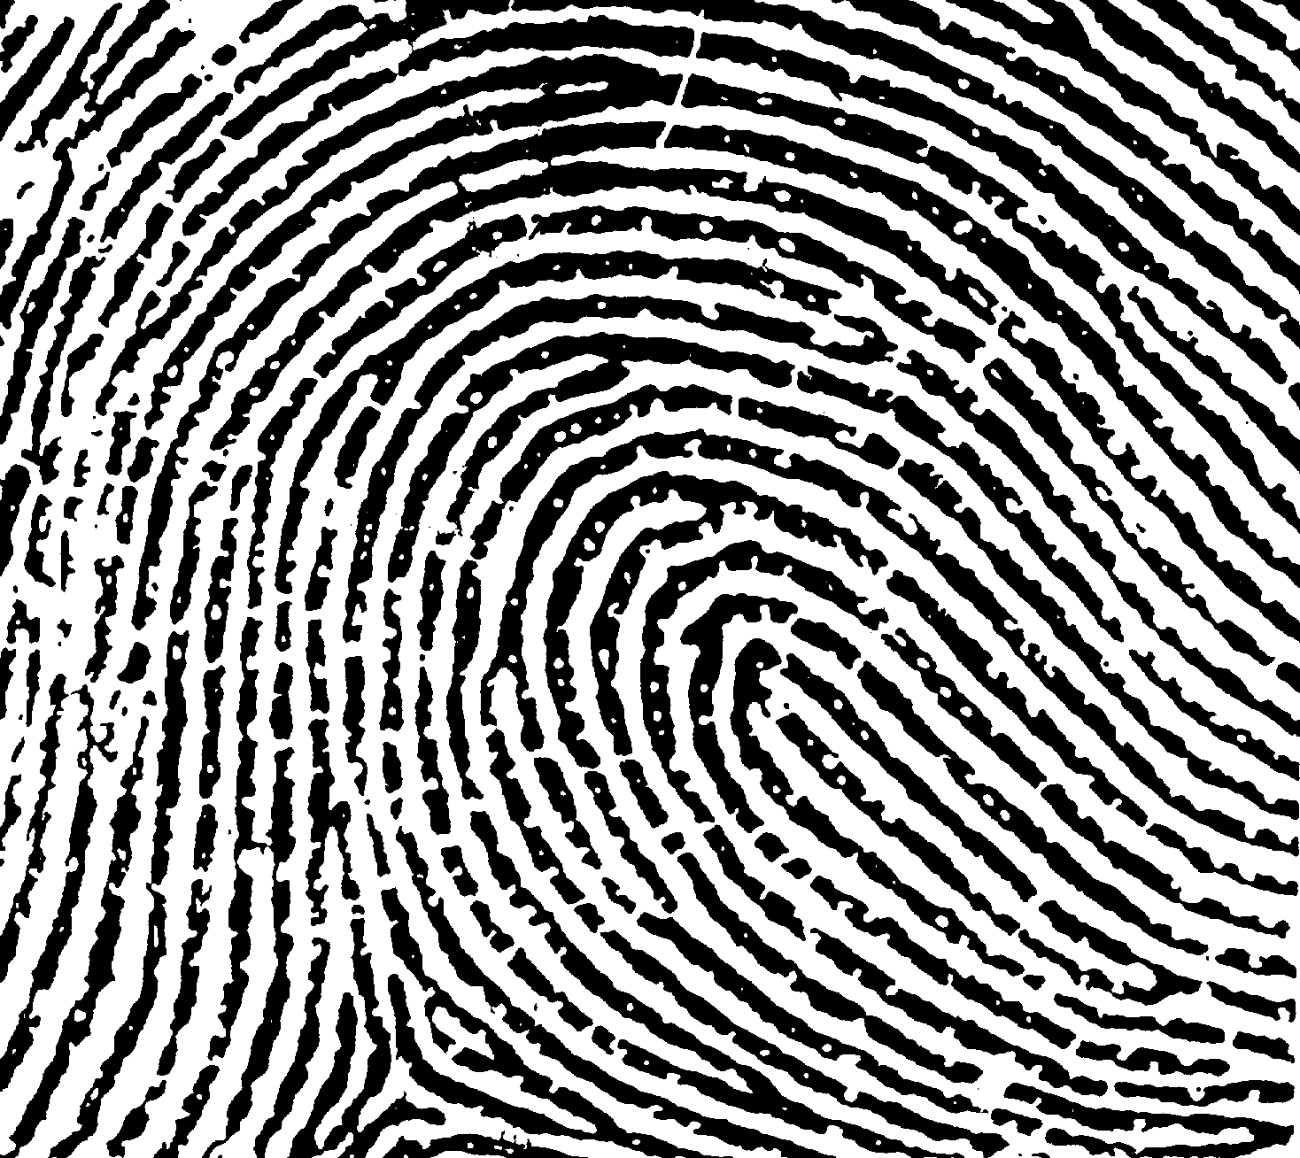
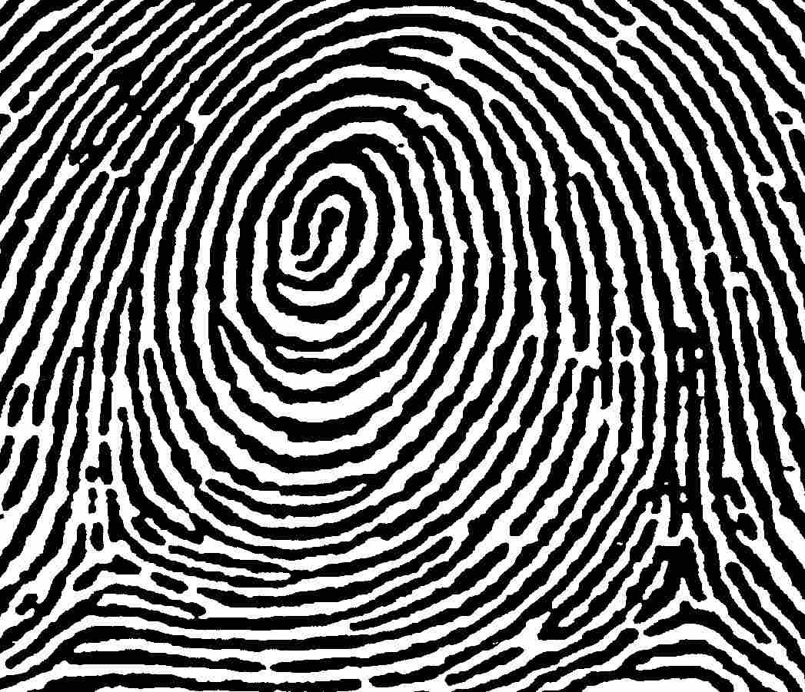

Loop Whorl
- To determine type of whorl:
Central Pocket Loop and Plain Whorl:
- Have at least one ridge (the spiral ridge) that makes a 360° circuit as a circle, oval, or spiral
- Plain Whorl: a line drawn between the two deltas crosses a spiral ridge
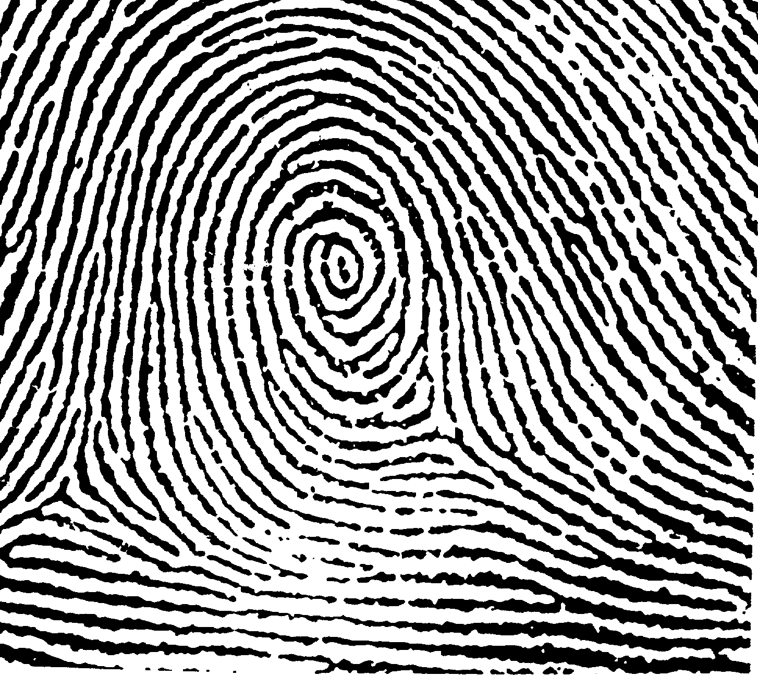
- Central Pocket Loop: a line drawn between the two deltas does not cross a spiral ridge

Plain Whorl Central Pocket Loop
Double Loop and Accidental:
- Double Loop: Two loops combined in the same pattern, usually opening in opposite directions
- Accidental Whorl: two or more patterns in the same print. For example, a loop + a plain whorl, or a loop + an arch, etc.
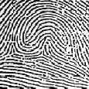
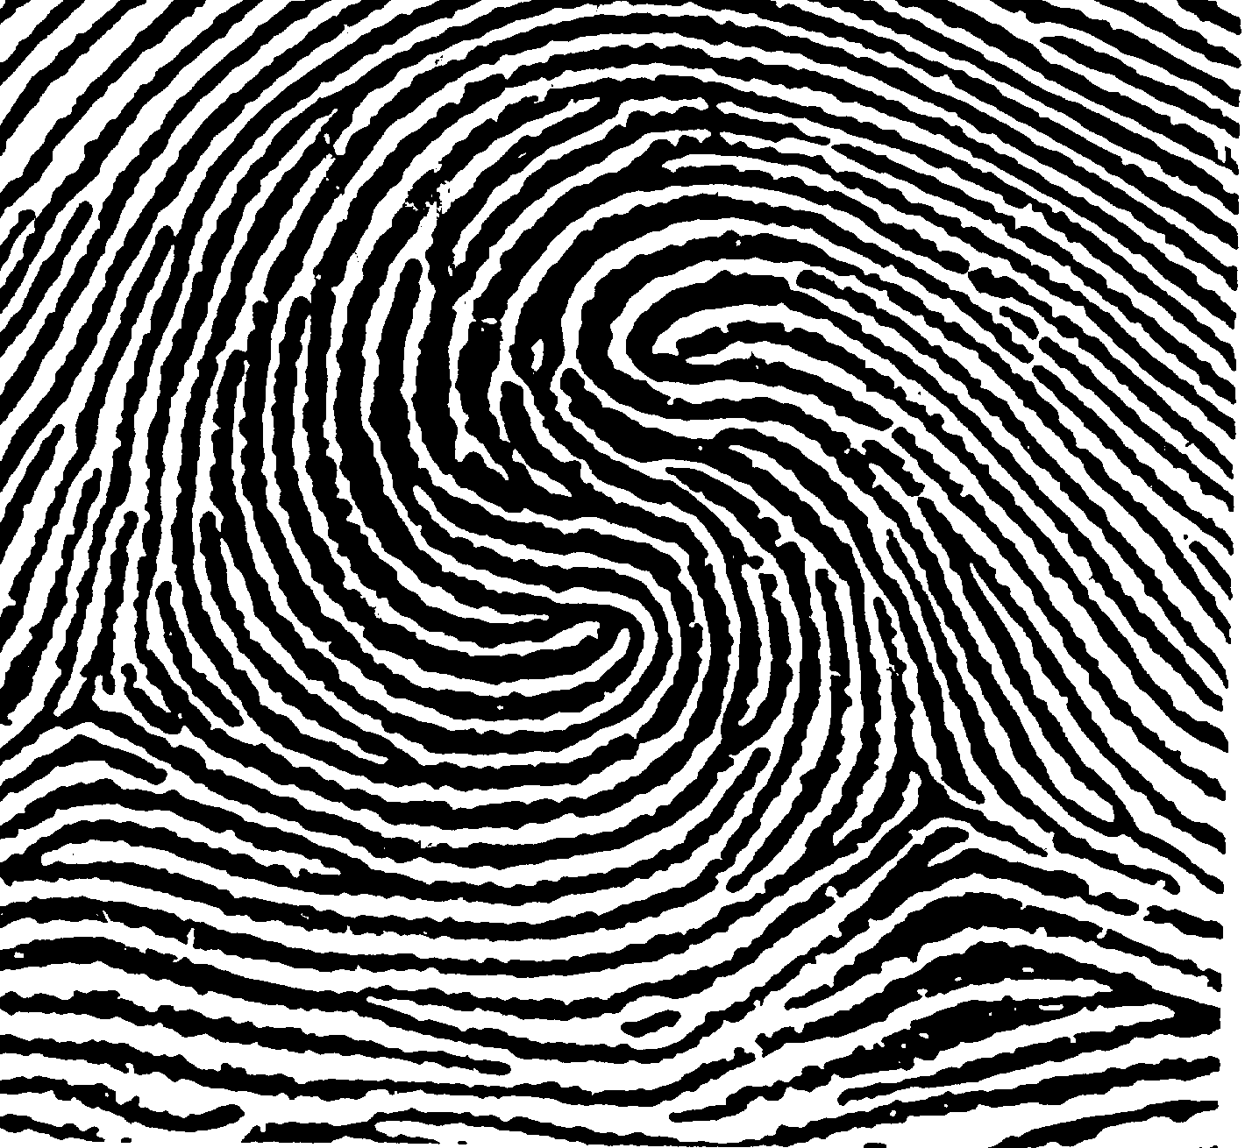

Double Loop Accidental
- To determine type of arch:
- Plain Arch: Ridges enter from one side of the pattern and exit out the other side
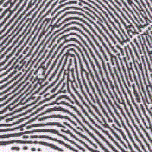
- Tented Arch: the center of the pattern contains a sharp up thrust. A tented arch may resemble a loop, but lacks one of the characteristics of a loop.
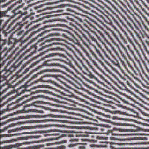

Plain Arch Tented Arch

 | Right Index  Finger Print | Basic Classification of Print  (loop, whorl, arch)  EXPLAIN your logic | Subcategory  EXPLAIN your logic
 | 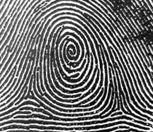
 | 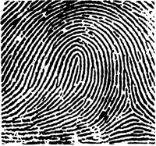
 | 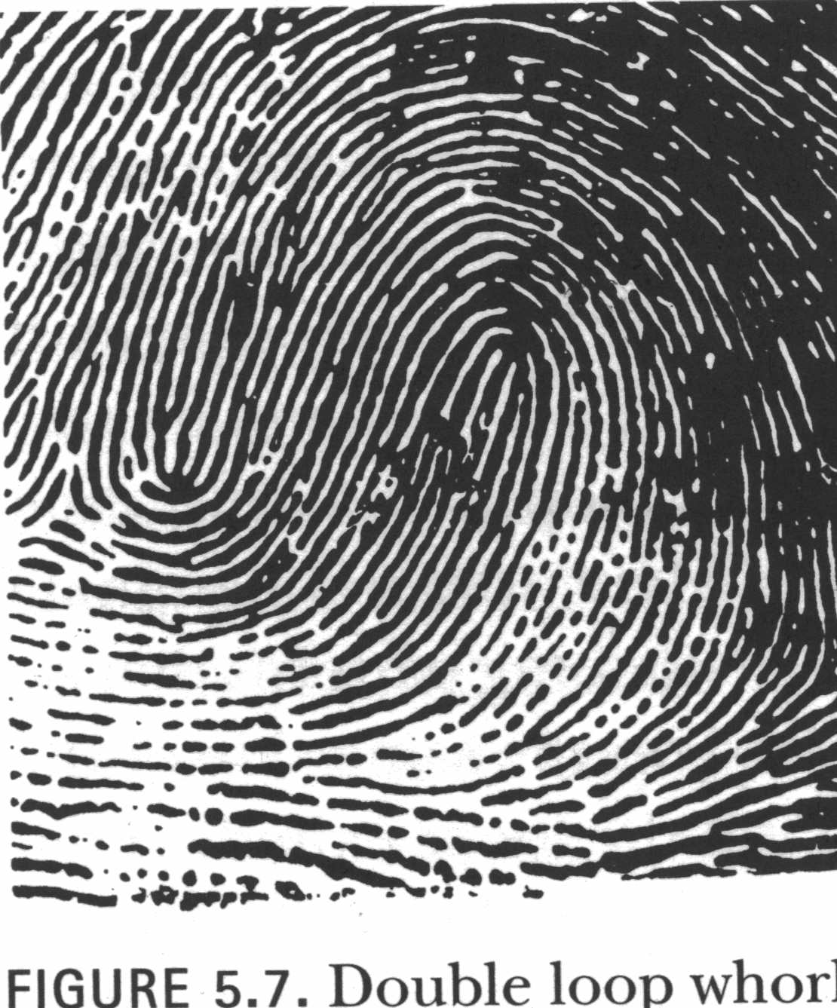
 | 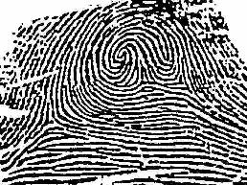
 | 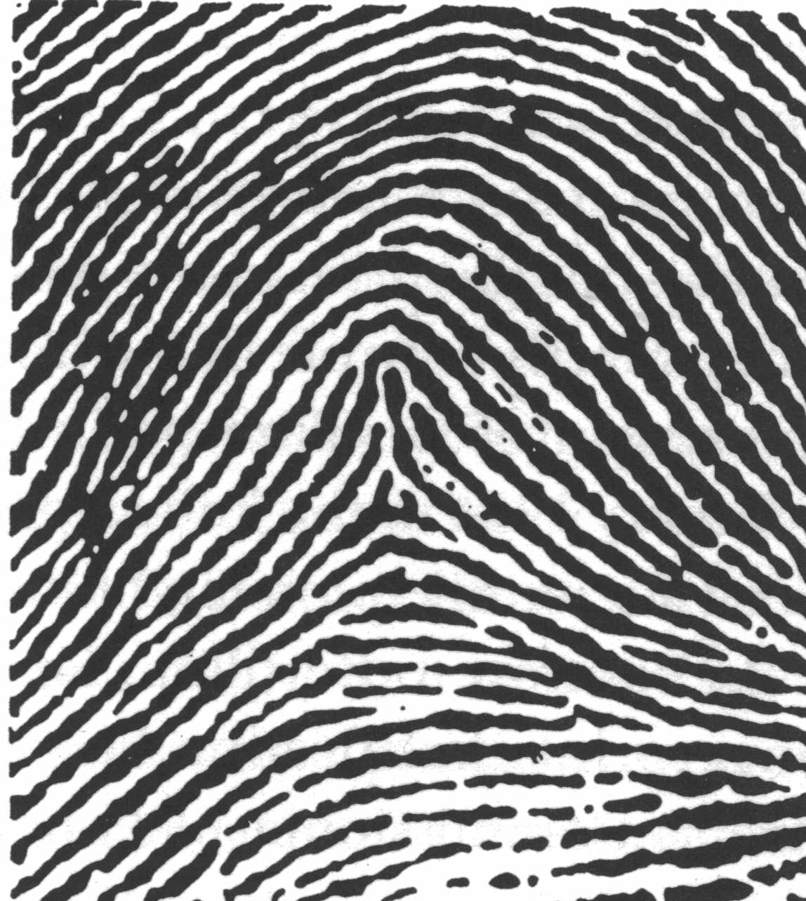

 | Right Index  Finger Print | Basic Classification of Print  (loop, whorl, arch)  EXPLAIN your logic | Subcategory  EXPLAIN your logic
 | 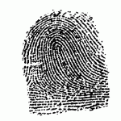
 | 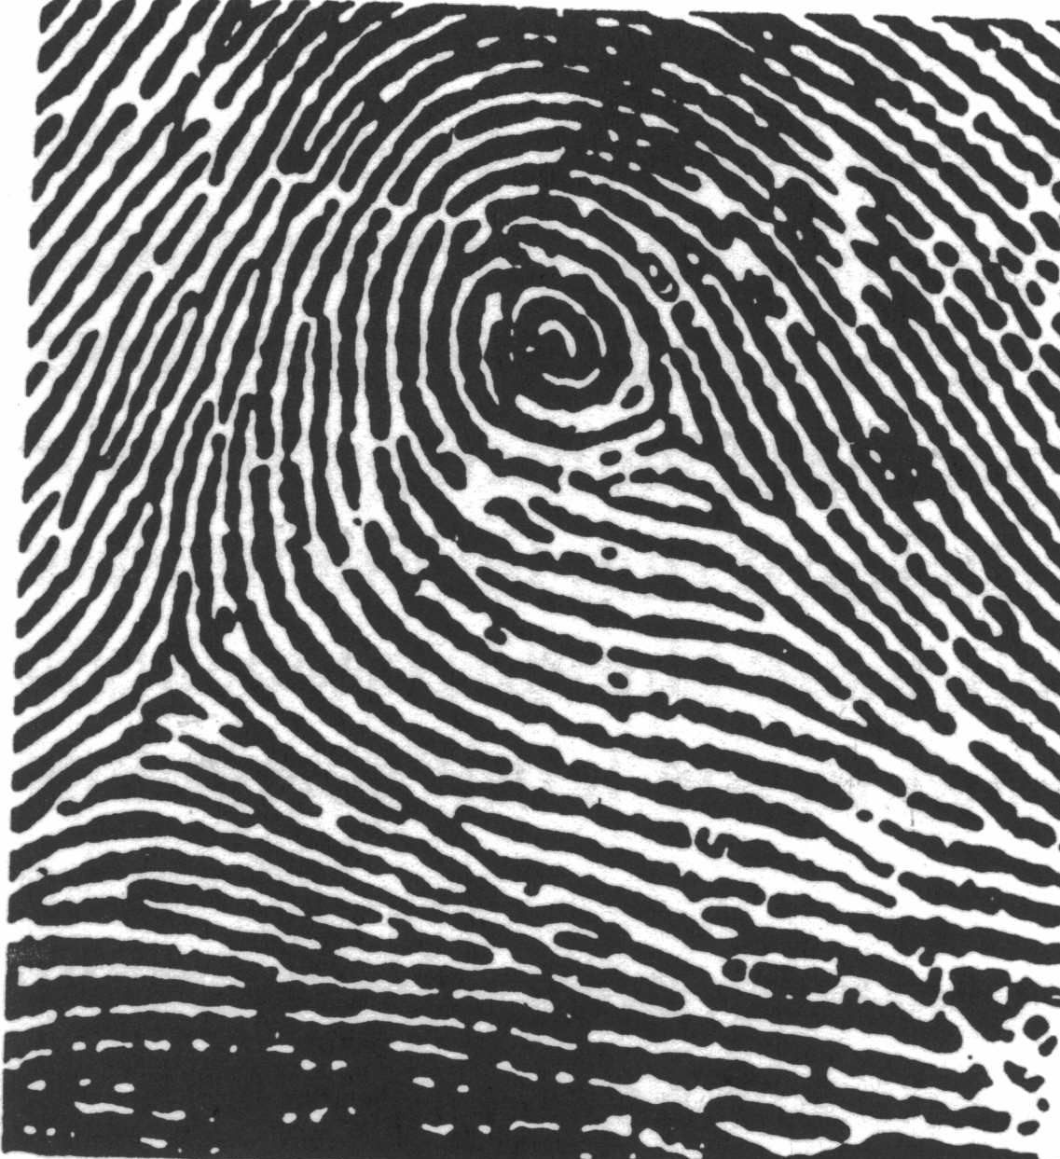
 | 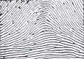
 | 

