Fiber Dye Lab Name ______________________ Forensics 352 – O’Dette Date _____________ Period ____

The color of cloth depends on the type of fabric and the specific dye used. A dye, whether it be a powdered drink mix or crushed marigold flower petals, will color each type of fabric differently. To test a new type of dye, on different fabrics, chemists often use a multi-fiber ribbon. The ribbon you will use is made up of thirteen different common fabrics. When this multi-fiber ribbon is dyed, each of the thirteen fabrics will be dyed differently. Notice the black thread next to the acetate end.
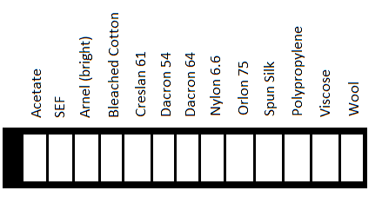
SEF = Self Extinguishing Fiber
Part I Dyeing a Multi-Fiber Ribbon with Powdered Drink Mixes
Several dyes used in the food industry are also useful for dyeing fabrics. Soak a piece of multi-fiber ribbon in each of the three warm solutions prepared from powdered drink mixes. After five minutes, remove the ribbon, rinse with warm water, dry with a paper towel, and staple to this chart.
Powdered Drink | Dyed Ribbon
 | (staple ribbon here)
 | (staple ribbon here)
 | (staple ribbon here)

Which fabrics are best for dyeing with powdered drink mix?
1st ______________________ 2nd ______________________

Part II Dyeing a Multi-Fiber Ribbon with Another Colored Liquid
Many food products can be used to dye cloth. Coffee, tea, boiled crushed flower petals, grape juice, etc. all can be used to dye certain kinds of fabric. Soak a piece of multi-fiber ribbon in each of the juices. After five minutes, remove the ribbon, rinse with warm water, dry with a paper towel, and staple to this chart.
(staple ribbon here)
(staple ribbon here)
Which fabrics are best for dyeing with cranberry juice?
1st ______________________ 2nd ______________________
Which fabrics are best for dyeing with grape juice?
1st ______________________ 2nd ______________________
Part III Dyeing a Multi-Fiber Ribbon with Mixture #1 and Mixture #2
Chemists use mixtures of dyes to help identify fabrics. When a multi-fiber ribbon is dyed with these mixtures, each type of fabric is dyed differently. Place a piece of multi-fiber ribbon into each of two dye mixtures. After five minutes remove the ribbon, rinse with water, pat dry and staple to this sheet
(staple ribbon here)
(staple ribbon here)

After the ribbons are dry, write the name of each color in the chart below. (Note: Be more descriptive than "pink". Several fabrics may fall in the spectrum of pink, so be descriptive!)
Fabric | Dye #1 Color | Dye #2 Color
Acetate
SEF
Arnel (bright)
Bleached Cotton
Creslan 61
Dacron 54
Dacron 64
Nylon 6.6
Orlon 75
Spun Silk
Polypropylene
Viscose
Wool

Part IV Identifying an Unknown Fabric Using Dye Mixtures #1 and #2
Now take your two unknown samples. Dye the first in dye mixture #1 for five minutes, then rinse with water, pat dry, and staple to this sheet. Then, repeat with the second unknown sample in dye mixture #2. Using the chart from Part III, you should be able to identify the type of fabric.
(staple unknown here)
(staple unknown here)

Unknown Fabric ID _________ Fabric Type ___________________________

